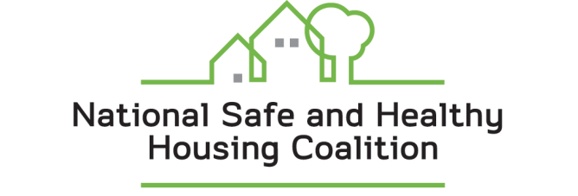

National Safe and Healthy Housing Coalition
Steering Committee Meeting

Home Safety Council
1250 Eye Street, NW, Suite 1000
Washington, DC 20005

Tuesday, January 26, 2010, 10:00-11:30 am

Call-In Number:
Ready-Access Number: 8005048071
7-Digit Access Code: 6894704

Meeting Objectives
- Learn more about relevant federal activities
- Find out about legislative, administrative and partnership activities
- Network
Agenda

10:00-10:10 Welcome and General Updates (R. Morley)

10:10-10:30 Federal Interagency Healthy Homes Task Force and Discussion (Peter Grevatt, EPA Office of Children’s Health Protection)

10:30-11:00 Workgroup Updates and Action Items
Federal Legislative Working Group – (Lars Peterson, Rebuilding Together)
Federal Regulatory/Administrative Working Group – (Patrick MacRoy, NCHH)
National Collaboration/Partnership-Building Working Group – (Patricia Adkins, Home Safety Council)

11:00-11:15 Organizational Sharing
What is your organization’s top priority right now as it relates to Healthy Housing?

11:15-11:30 Next Steps and Open Networking (R. Morley/all)

